**Task 1:-**

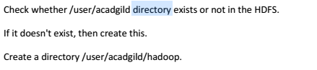

**Explanation:-**

First, we need to check whether /user/acadgild directory exists or not. We can check in HDFS using **–d** option under **test** command. If the directory exists, **then –d option in test command will return 0**. If directory **does not exists, then 1 will be returned.** Note that **“$?”** will store the status of the last command.

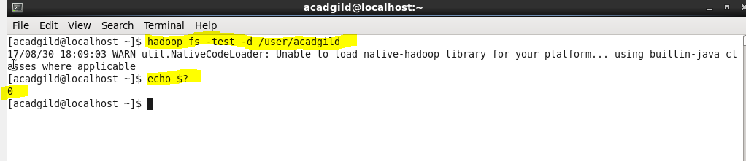

As per the above screenshot, the value returned is 0. So, we can say that directory named “**/user/acadgild**” exists.

Now we need to create a directory named **/user/acadgild/hadoop.** We can create it using **mkdir** command as shown in the below screenshot.

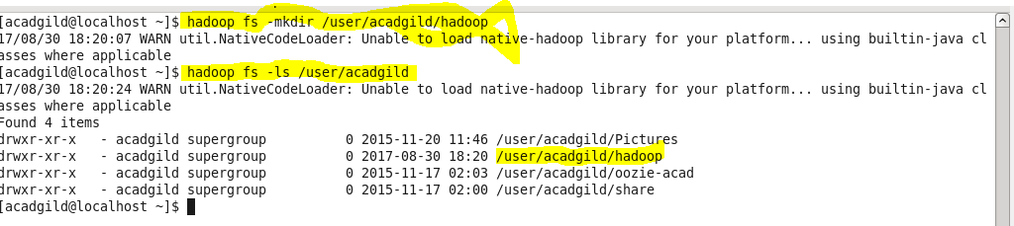

If you notice the previous screenshot, directory named **/user/acadgild/hadoop** is created.

**Task2:-**

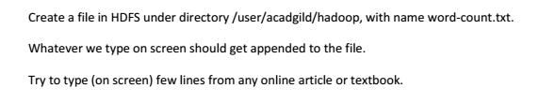

**Explanation:-**

Using **touchz** command, we can create empty file under the directory.



From the below screenshot, it is proven that under **/user/acadgild/hadoop** directory, **word-count.txt** file is created.

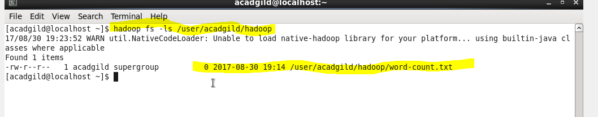

Now we can append the input lines into the file in HDFS using **appendToFile** command.

For example,

In the below screenshot, the lines entered in the double quotes will be echoed and appended into the **word-count.txt** file using **appendToFile** command.

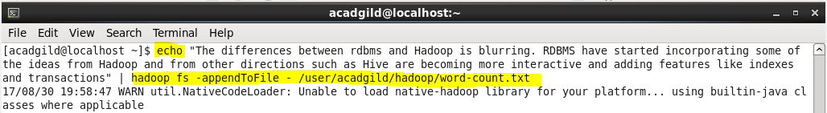

Now I have displayed the file named **word-count.txt** under **/user/acadgild/hadoop** directory.

